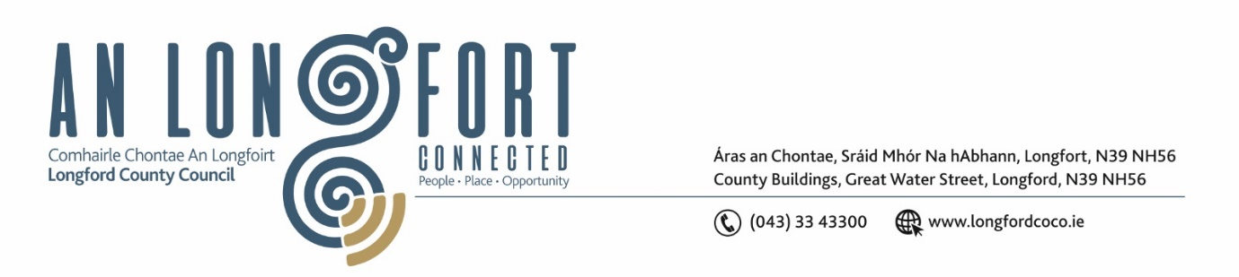

GRANARD MUNICIPAL DISTRICT

Please note meeting will be held in Granard Library.

21 November 2023.

To: Each Member of Granard Municipal District.

Dear Member,

You are requested to attend a Meeting of Granard Municipal District to be held in Granard Library on Tuesday 28th November 2023 at 3.30pm to transact business, as set out on the Agenda hereunder.

Yours sincerely,

______________________
Claire McNabola,
Meetings Administrator

AGENDA

Prayer before meeting.

1. Confirmation of Minutes as follows: -

- Granard Municipal District Meeting held on 26 September 2023 – enclosed.
- Granard Municipal District Committee Meeting held on 26 September 2023 – enclosed.
- Granard Municipal District Meeting held on 24 October 2023 – enclosed.
- Granard Municipal District Committee Meeting held on 24 October 2023 – enclosed.

2. Matters arising from Minutes.

3. Declaration of Interest by Members.

4. Management Report incorporating Area Engineer’s Progress Report – enclosed

5. Community Climate Action Fund

6. Update on drawdown of Community Support Grants and Special Projects/Discretionary Grants 2023

7. Part VIII No. 112 - Proposed construction of 1 No. 2 Bedroom single storey house, including boundary walls/fences, car parking, entrances, landscaping, on site wastewater treatment system, connection to existing services and associated site works

8. Proposed dates for 2024 MD meetings

9. Notices of Motions, submitted by Councillors, as listed hereunder:

Councillor Garry Murtagh
- Calling on Longford County Council to install speed ramps at the entrance to Dring car park. There are a large volume of people using this facility as a camp site and a meeting place. It has been brought to my attention that the car park area is approached at high speeds with there are a lot of children running around enjoying the freedoms of Dring.

- I call on Longford County Council for a Low Cost Safety Scheme at Legga Cross.

Councillor Turlough McGovern
- I call on Longford County Council to upgrade footpath on Market Street (from the Barbers shop to Ptb yard entrance) in line with the opposite side recently worked on.

- I call on Longford County Council to put in place a plan for the two derelict buildings owed by the Council since 2018 (property on Main Street) and 2022 (property on Market Street) as they are eyesores in the main town and Granard Tidy Towns are hindered by these in progressing with their work.

- I call on Longford County Council to consider a Safety Awareness plan for outside Convent of Mercy School on N55 ie. put in place pencil bollards as the amount of near miss accidents are at risk of being a serious accident and I want the safety of the children to be the priority in getting this done ASAP.

10. Correspondence

